Dear Parent / Guardian

**St Clare’s are hosting a FREE, engaging and fun-filled holiday clubs for three weeks of the Summer Holidays. Please note that you have to book each day and each week separately.**

**Week 1 is: Mon 29th – Thurs 1st August**

**Week 2 is: Mon 5th August – Thurs 8th August**

**Week 3 is: Mon 12th August – Thursday 15th August**

Each club runs from Monday – Thursday **from 9:30-2pm**. Designed to provide a safe and stimulating environment for your child during the week, Bring it on Brum! SOS holiday clubs guarantee your child an unforgettable experience packed with exciting activities and opportunities for learning and socializing.

Activities include sports and games, arts and crafts, cookery, dance and music. All clubs provide a nutritious and delicious meal too! Programmes vary depending on location.

**Eligibility Criteria**

If your child is aged between 4-16 and is eligible for benefits-related free school meals, then they are entitled to access Bring it on Brum! holiday clubs for FREE (there is a small charge of £10 for non FSM pupils but please book first and then arrange with the provider on the day). Please check with school if you are unsure if your child qualifies for free school meals.

**Booking Information**

Your Bring it on Brum! code is: 3303406 Please book via the Bring it on Brum! website at: [www.bringitonbrum.co.uk](http://www.bringitonbrum.co.uk).

**All you have to complete the booking form is type in B20 3RT under POST CODE AND THEN search.**

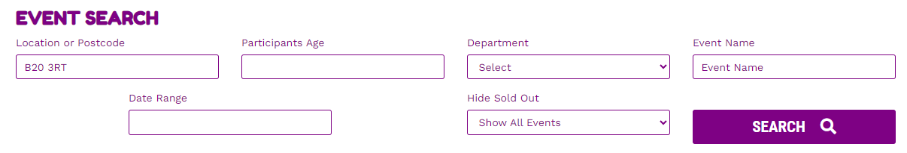

**Then click on More Information to book:**

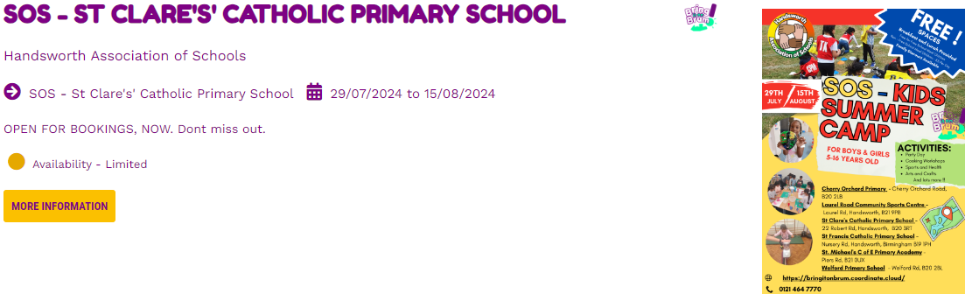

**Scroll across to choose St Clare’s and BOOK Now - This is a quick and easy process and you can choose any days (or the whole week) if you wish. You can book for more than one week if you wish. Please note that I would recommend you book as soon as possible as places are limited.**

**Remember the BIOB/HAF code is 3303406**

We hope you make the most of this fantastic opportunity!

Warm regards

Mr Murphy