
Mathematics

Year 4 pupils follow a carefully designed scheme of learning that covers all the national curriculum objectives like place value, addition and subtraction, multiplication and division, fractions, decimals, measurement, shape, and statistics.

We use oracy in maths to encourage full-sentence responses and clear reasoning rather than one-word answers such as…

“I know this because…”
“I noticed that…”
“Another way to solve it could be…”
“I agree/disagree with ___ because…”

English
We will reading a variety of fiction and non-fiction texts.
We will immerse pupils in the text using oracy to consolidate understanding and use drama to bring texts alive. Writing opportunities will include story writing, performance poetry and information to inform the reader.
We will teach grammar, spelling rules and handwriting explicitly weekly.

Oracy
At St Clare’s we are teaching children how to talk and listen well — not just for communication, but as a tool for thinking, learning, and building confidence.
WHY?
Helps children explain their ideas clearly. Builds confidence in speaking in class and beyond. Improves listening skills so they can learn from others.

Strengthens reading and writing by boosting vocabulary.

Year 4 Autumn 2025
Dignity of the Human Person

Religious Education

Creation
To understand the stories of creation, Abraham and Isaac, Jacob and Joseph from the Old Testament. To know that human beings were made in the image and likeness of God and that we are all special.
Jesus teaches us to pray
To know that Jesus prayed to God the Father and recognise some prayers he learned growing up. To understand that Jesus grew up as a Jew and can explain why it is important to call and to pray to God the Father.
P.E.
Children must attend school wearing their PE outfit on Monday and Tuesday. This term, the children will be learning skills in football, gymnastics, dance and badminton.
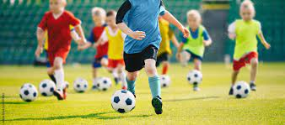
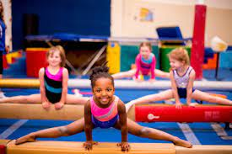
Science
The children will be learning about animals including humans. They will learn about skeletons and healthy eating. They will also learn about states of matter, the differences between solids, liquids and gases, classifying objects and identifying their properties. The children will work scientifically and collaboratively to investigate the weight of a gas.

Geography & History
In Geography, we will learn about the UK and our local counties, towns and cities.
In History, we will focus on Tudor Monarchs and the daily life for the people of Britain during the Tudor period.

Art-: In Art, we will be exploring ‘still life’ and will be making observational drawings of nature inspired by our chosen class artist.

D&T: - We will be using all of our senses and all of the food groups, to create a tasty and nutritious salad.

PSHE/ Happy Minds
Throughout this term, we will explore the themes of self-care and respecting the needs of others. Happy minds sessions allows pupils to understand their emotions and how to deal with difficult situations.

##


Year 4 Autumn 2025
Dignity of the Human Person

Computing
We will be learning:
-how to use an internet search engine while remaining safe online.
-sequencing and looping animations using Code and Scratch software.

Jesuit Values/ Gospel values
This half term, the children will be thinking about being grateful and generous. They will listen to readings, which gives examples of these virtues from the Bible as well as discussing times they can be grateful and generous which it is so important.

Music
We will develop our understanding of pulse and rhythm while learning to play the Djembe.
French The children will be learning important every day French vocabulary and will learn how to talk about themselves in French.

Other opportunities
Pupils will participate in class assemblies, class mass and perform poetry on stage.
Trips/visitors
Pupils will be given the opportunity to participate in field trips. Trips to local attractions.

