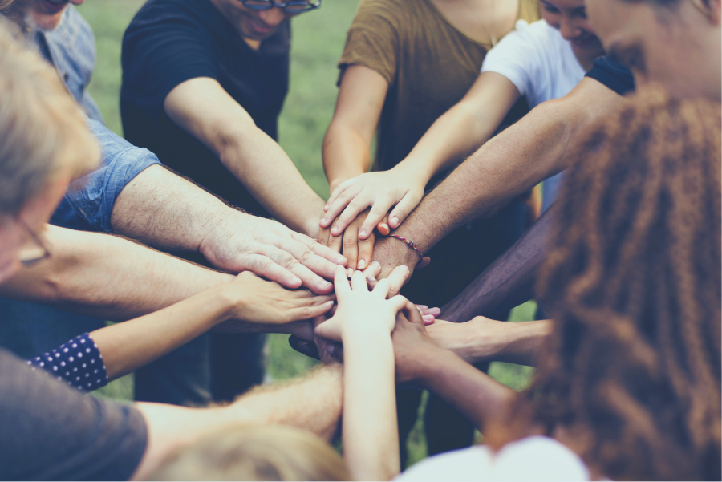
Mathematics

This term the children will be learning the place value of four digit numbers.

They will us this knowledge to add and subtract numbers up to 1000 using mental and written methods.

In addition, the children will be learning the four, six and eight timetables and division facts.
Literacy
We will reading a variety of fiction and non-fiction texts. We will immerse pupils in the text using oracy to consolidate understanding and use drama to bring texts alive. Writing opportunities will include story writing, performance poetry and information to inform the reader.
We will teach grammar, spelling rules, dictation and handwriting weekly.
We will learn spelling rules and patterns and will have a weekly spelling test.

Talk time /Speaking and Listening
Mathematical language If you…then………………….. First……………….. After that………………………I know…………………..because…………… ……… …….and……. are alike in that……………………. / ………and…….are similar because………… ………….is………….but………..is………… …… / ……..is………while………is………….. When…, / If…... So Finally I……………………..

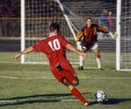
Year 3 Autumn
Dignity of the Human Person

Science
The children will be learning about Animals including humans. They will learn about skeletons and healthy eating. They will also learn about light, looking at how shadows are cast, reflection and identifying different light sources.
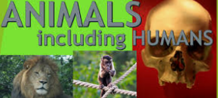

Religious Education

To know that Baptism is the Sacrament of Belonging to God’s Family, the Church.
They will be able to identify some signs and symbols of Baptism and express their meaning.
They will be also be able to sequence the Rite of Baptism and be able to discuss elements
The children will know some teaching of Jesus about the forgiveness of sin when wrong choices have been made.
They will understand that the Sacrament of Reconciliation is the Church’s celebration of God’s forgiveness of sin.
P.E.
Children must attend school wearing their PE outfit. This term, the children will be learning skills to play Football and develop Gymnastics.
Geography & History
In Geography, we will learn about the UK and our local county, town and city. We will create ‘messy’ maps of a local village and begin to read the signs and symbols on a map.
In History, we will focus on Tudor Monarchs and the daily life for the people of Britain during the Tudor period.

Art-: In Art, we will be exploring ‘still life’ and will be making observational drawings of nature. We will be exploring the artwork of Pam Sym-who is the illustrator our class text-LOB.
D&T: - We will be using all of our senses and all of the food groups, to create a tasty and nutritious salad.

PSHE
Throughout this term, we will explore the themes of self-care and respecting the needs of others. This will be taught through all subjects.

##

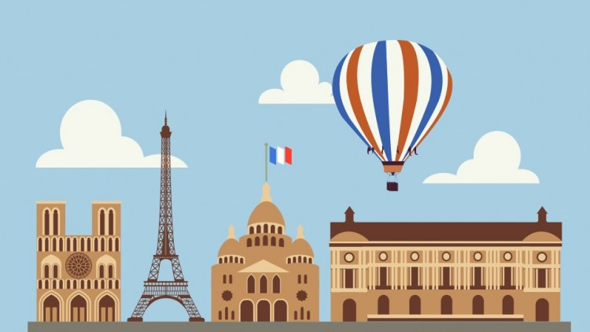
Year 3- Autumn
Dignity of the Human Person

Computing
We will be learning:
-how to use an internet search engine while remaining safe online.
-sequencing and looping animations using Code and Scratch software.

SMSVC/ Gospel values
This half term, the children will be thinking about being Eloquent and Truthful. They will listen to readings, which gives examples of these virtues from the Bible as well as discussing times they can be eloquent and truthful which it is so important.

Music
We will develop our understanding of pulse and rhythm while learning R&B, Western Classical, Musicals, Motown and soul.
French The children will be learning important every day French vocabulary and will learn how to talk about themselves in French.

Other opportunities
We hope to arrange a lunch and hymn concert for the local elderly community.
Trips/visitors
Pupils will be given the opportunity to participate in field trips and visit local attractions.

