

[](https://www.google.com/imgres?imgurl=https://www.westernprimary.co.uk/wp-content/uploads/2017/07/SEN-Image1.jpg&imgrefurl=https://www.westernprimary.co.uk/3412-2/sen-information/&docid=lB_g-_4YsIs7dM&tbnid=pGY66ft80Pe0BM:&vet=10ahUKEwjj1qz4nIbgAhWMRBUIHd-rC7sQMwhYKA0wDQ..i&w=1600&h=738&bih=673&biw=1024&q=SEN%20CHILDREN&ved=0ahUKEwjj1qz4nIbgAhWMRBUIHd-rC7sQMwhYKA0wDQ&iact=mrc&uact=8)

St Clare’s Catholic Primary School

Special Educational Needs Report

Our Mission Statement

We welcome everyone into our community in order to live, love and learn together in the light and example of the life of Christ.

My name is Mrs Kavanagh and I am the SENDCo (Special Educational Needs and Disability Co-ordinator) here at St Clare’s. I work with children, parents, teacher, teaching assistants and various support agencies to ensure that the needs of our children are met. At St Clare’s, we are committed to ensuring that all children become independent learners and reach their full potential. We aim to identify children’s individual and specific areas of need early in their school life and to make appropriate provision and reasonable adjustments to meet their needs.

I am always happy to talk to you about any concerns you may have about your child. We offer two drop in sessions twice a week from 8:30 to 9:00 on a Tuesday and Thursday morning, where either myself or a members of my team are available to talk to:

Mrs C McGuire, from our mentoring team, Mrs V Rivett, and, Mrs S Kainth+ on a Thursday for Speech and Language team. Alternatively you can make an appointment to see me or email me at: [a.kavanagh@stclare.bham.sch.uk](mailto:a.kavanagh@stclare.bham.sch.uk) 0121 554 3289.

Should you wish to know more about the Birmingham’s approach (Local Offer) to Special Educational Needs and Disability (SEND) you can find lots of information at:-

[www.localofferbirmingham.co.uk](http://www.localofferbirmingham.co.uk)

Under the new Special Educational Needs and Disability code of Practice (DfE 2015) schools are expected to provide SEND information with regards to:

* Open and Honest Communication
* Appropriate and Effective Teaching and Learning
* A Partnership Approach



Open and Honest Communication

* If you have any concerns about your child’s progress, please speak to your class teacher initially who will liaise with the SENDCo.
* If you would like to discuss these concerns further with Mrs Kavanagh (SENDCo) then please make an appointment or call into one of our drop in sessions. You can contact Mrs Kavanagh by telephone 0121 554 3289 or emailing her at [a.kavanagh@stclare.bham.sch.uk](mailto:a.kavanagh@stclare.bham.sch.uk)
* At St Clare’s we hold termly parent/teacher consultations during the day providing opportunities to discuss progress, interventions happening within school and how best to support your child at home. We value both ‘parent and children’s voice’ in order to gain an overall picture of the child’s needs and how best to support them.

How do we share information?

* Our SEND policy is published on our school website. The policy explains how we identify and assess children who we think might have special educational needs. This policy is reviewed regularly ensuring we provide the most up to date information.
* At St Clare’s we make provision for pupils who have additional learning needs. There are four areas of need: Communication and Interaction, Cognition and Learning, Social, Emotional and Mental Health Difficulties and Sensory and/or Physical Needs.

Communication and Interaction

Type of Need

Children who find it difficult to interact and communicate with people and the world around them.

Some children find it difficult to:-

* Talk to other adults and children,
* Follow rules set by others
* Sitting still for a long period of time
* Listen to and follow instructions
* Understand how they are feeling
* Make new friends
* Deal with their difficulties in a way that does not cause harm to themselves or others
* Take responsibility for things they do
* Being rational about worries/concerns

Examples of how we can support the children:

* Teachers change what they are teaching or the way they help children to learn
* Extra support may be given in a small group or individually with an adult supporting the child as they learn.
* In exceptional circumstances, a reduced timetable may be used, with agreement from parents, as part of a re-integration or as part of a package to avoid exclusions, fixed-term or permanent and with the aim of providing a higher level of adult support
* Extra support can be given to the child throughout the day for a short time or a set session to let them talk about the things that upset them – either with the behaviour mentors and/or with a specific adult in school.
* Individual targets are set on support plans to help show the child and anybody working with the child what needs to be worked on.
* Access to specialist support e.g. refer to SALT

How will the support be monitored?

* Observations of the child to see if they are communicating or interacting
* Communication takes place between other professionals working with the child to assess and review the level of support needed
* A tri-annual audit of the child’s learning needs in speaking and listening and when the child has achieved each target.
* Regular communication takes place between adults working with the child.
* Regular communication takes place between the SENDCo and the adults working with the child.
* Support plans are shared at every parent’s consultation and all parents are given a copy of their child’s targets to keep at home.
* Regular review meetings are held with the SENDCo for all children on target cards
* Involve the child in the review process of their targets.

.

Cognition and Learning

Type of Need

Children who find learning, thinking and understanding more difficult than most other pupils. Some of the things children with these difficulties might find harder than most:-

* Find they take longer to learn important skills
* Find it difficult to remember things
* Find it hard to understand how to use letter sounds to read and spell words
* May find they need more time to think about their answers

Examples of how we can support the children:

* Teachers adapt the curriculum or change the way they are teaching or the way they help the children to learn.
* Extra support may be given in small groups or individually with an adult supporting the child as they learn.
* Extra adult support may be provided throughout the day for short time periods or for specific activities
* Individual targets are set on care plan or pupil profiles to help show the child and adults working with them specific areas of need.
* Access to specialist support from a teacher or other professionals.

How will the support be monitored?

* The child’s targets are assessed and evaluated regularly and dated to show when the child has achieved them
* Regular Communication takes place between adults working with the child
* Regular Communication takes place between the SENDCo and adults working with the child.
* The school tracking system is used to see how much progress the child has made.
* Termly pupil progress meetings with the class teacher and the Head teacher/SENDCo to review how the child is progressing.
* Communication takes place between other professionals working with the child to assess and review the level of support needed.
* A tri-annual audit of the child’s learning needs in speaking and listening, reading and writing takes place to track progress and areas for improvement.
* Support plans are shared at every parent’s consultation and all parents are given a copy of their child’s targets to keep at home.
* Review meetings are held with the SENDCo for all children on an Care plan.
* Pupil self-evaluation

.

Social, Emotional and Mental health Difficulties.

Type of Need

Children who find it difficult to manage their emotions and behaviour in a way that affects their daily life.

Some of the things children with these difficulties might find harder than most:

* Following rules set by others.
* Listening to and following instructions.
* Sitting still for very long
* Understanding how they are feeling.
* Making friends.
* Dealing with their difficulties in a way that does not cause harm to themselves or others.
* Taking responsibility for things they do.
* Being rational about worries/concerns.
* Children who have experienced trauma or family death.

Examples of how we can support the children:

* Get advice from professionals and specialist staff trained in school to give advice to adults working with the child.
* Extra support may be given in a small group or individually with an adult supporting the child as they learn.
* In exceptional circumstance, a reduced timetable may be used, with agreement from parents, as part of a package to avoid exclusions, fixed-term or permanent and with the aim of providing a higher level of adult support.
* Extra support can be given to the child throughout the day for a short time or a set session to let them talk about the things that upset them – either with the behaviour mentors and/or with a specific adult in school.
* Regular communication between home and school.
* Individual targets are set on support plans to help show the child and anybody working with the child what needs to be worked on.
* Access to professional support services – e.g. Educational Psychologist

How will the support be monitored?

* Observations of the child to see if they are coping better in school following intervention or to assess areas of support still needed
* The child’s targets are assessed and evaluated regularly and dated to show when the child has achieved them
* Regular communication takes place between adults working with the child.
* Regular communication takes place between the SENDCo and the adults working with the child.
* Support plans are shared at every parent’s evening and all parents are given a copy of their child’s targets to keep at home.
* Regular review meetings are held with the SENDCo for all children on target cards/success cards.
* Involving the child in the review process of their targets.

Sensory and/or physical needs.

Type of Need

Children who have a disability that may make it difficult for them to manage their everyday life without adaptations or support.

This may be because of a hearing or visual impairment or physical disabilities or other medical needs.

Some of the things children with these difficulties might find harder than most:

* Hearing what others say in the classroom or school setting.
* Reading words on books, worksheets or whiteboards that are not made bigger or changed to help them
* Moving around without the aid of a walking aid or wheelchair.
* Using pencil, scissors, knives and forks and other things that require fine motor skills.
* Taking medication without adults helping them.
* Managing the sensations the environment around them provides.

Examples of how we can support the children:

* Teachers adapt the curriculum or the way they help the child learn.
* Extra support may be given in a small group or individually with an adult supporting the child as they learn.
* In exceptional circumstance, a reduced timetable may be used, with agreement from parents, as part of a re-integration
* In exceptional circumstance, a reduced timetable may be used, with agreement from parents, as part of a re-integration package with the aim of providing a higher level of adult support
* Teachers change what they are teaching or the way they help the child learn.
* Extra support may be given in a small group or individually with an adult supporting the child as they learn.
* Regular communication between home and school.

Individual targets are set on support plans to help show the child and anybody working with the child what needs to be worked on.

How will the support be monitored?

* Monitoring that the child has full access to a broad and varied curriculum.
* Observations of the child within the school environment.
* The child’s targets are assessed and evaluated regularly and dated to show when the child has achieved them.
* Regular communication takes place between adults working with the child.
* Regular communication takes place between the SENDCo and the adults working with the child.
* Support plans are shared at every parent’s evening and all parents are given a copy of their child’s targets to keep at home.
* Involving the child in the review process of their targets.

How does the school identify and assess Special Educational Needs?

At St Clare’s we identify special educational needs in the following ways:

* Observations
* Audit assessments
* Referral to SENDCo
* Independent Target Plans/Pupil Profiles
* Communication with parents
* Information from child
* Information from all adults working with the child
* Specialised/Standardised assessments carried out by members of our school’s support services eg educational psychologist, pupil school support, speech and language therapist
* Information from a previous school setting.
* Information from previous pupil progress meetings
* End of year results.

Once a child is identified as having special educational needs a graduated approach to support is taken – assess, plan, do, review.

If English is not your first language, we will do our best to provide an interpreter (from our multi lingual members of staff) to help you communicate with school and external agencies

Our governing body has a governor who is responsible for special educational needs. Her name is Miss V. Middleton.

What happens if there is a concern about your child’s progress.

If additional support is necessary, a plan will be agreed for support in school.

Your child’s teacher with support from the SENDCo will assess if your child needs additional support

You, your child or their teacher have concerns about your child’s progress.

If we still have concerns then the SENDCo may arrange for someone from a support agency to come and work with your child and give us advice about new or different types of support we can try. You will always be told about this and there is usually an opportunity for you to meet these people at school.

Support will be put in place and we will talk to you and your child regularly about how things ae going and if any changes need to be made.



St.Clare’s works with a lot of external agencies to help identify specific needs. Some of these are:

* Forward Thinking Birmingham
* Communication and Autism Team Mrs E Tyndell
* Educational Psychology – Mrs A Rowledge
* Pupil and School Support – Ms S Kearns
* School Nurse – Mrs G Prentice
* Physical Disabilities Support Service. Mrs S Paddock
* Speech and Language Therapy – Mrs Victoria Woolridge
* Fr Hudson Family Support Service is – Mrs J Ranson

Should we feel that your child needs support from one of these services, we will always consult with you and request written consent to do so.

Mrs Kavanagh will make sure that all necessary school staff are aware of your child’s needs and concerns.

* Your child’s teacher will be responsible for supporting your child’s needs in school. They will do this with the support of Mrs Kavanagh and people from other support agencies as necessary.
* If your child has been identified as needing additional support then an Individual Care Plan and/or a One Page Profile will be written and shared with you and any staff working with your child.
* If your child has medical needs then a Personal Care Plan may be written in consultation with the school nurse and shared with all staff in school.
* All these different types of plans will be reviewed on a regular basis and we will talk to you and your child at parents’ consultation afternoons or at review meetings about progress and/or changes that need to be made.
* All staff have access to a copy of these plans. The plans identify how your child will be helped to succeed and make progress. Occasionally, your child’s teacher may not be in class and this extra information is useful for the covering teacher.
* If you want to talk to someone in between these times please speak to your child’s teacher or contact Mrs Kavanagh.

Should your child move to a new school, the SENDCo from both schools will ensure that all relevant information is shared.

Moving to Secondary School

When your child moves from Year 6 to secondary school, Mrs Kavanagh will ensure that all information regarding your child’s special educational needs are passed to the new SENDCo. Extra visits to the secondary may be arranged and sometimes the new SENDCo will come to review meetings held at St. Clare’s School.

* In the summer term, meetings are held with Mrs Kavanagh, parents, children and the SENDCos of the secondary schools to make sure that all relevant information is passed on. Children’s Care Plans are passed on to new schools so that a summary of information is available to new staff.
* If appropriate, the SENDCo will make an application to a school with a specialist provision to meet an individual child’s needs.
* Children with SEND are invited to extra transition days at their new secondary schools.
* Familiar resources used at St. Clare’s may be taken on a visit to the new school.
* Support is given by all staff working with a child to reassure them that they will benefit from a place at a specialist provision if appropriate.

How will my child’s progress be reviewed and when will I be invited into school to discuss this? Will my child be able to give their views?

* Teachers monitor your child’s progress with regular assessments, matched to national and age-related expectations.
* They complete termly tracking documents.
* The Individual Target Plan is reviewed at least once each term.
* Children who are not making expected progress are picked up through the regular review meetings that follow these assessments.
* This may lead to adjustments to their Individual Target Plans and to the support they receive.
* Your child’s teacher will talk to you about their progress at least Once a term,

but if you want to talk to them or Mrs Kavanagh it is always possible to make an appointment at any point in the school year.

* Sometimes your child will have some targeted support as part of their normal learning experience but if your child is identified as needing additional support because of a special educational need then a plan will be put in place and this will be shared with you and your child.

Appropriate and Effective Teaching and Learning

How are our staff trained to support the needs of all children?

* Mrs Kavanagh ( SENDCo) has completed and passed the National Award for Special Educational Needs Coordination ( NASENCO), holds Tier 3 Certificate in Autism, completed Deputy Safeguarding Lead, Master in Special Educational Needs.
* All our class teachers are fully qualified and receive continuing professional development, including training about Special Educational Needs throughout their teaching careers.
* Further training on specific Special Educational Needs topics are a regular feature of the staff professional development calendar each year.
* Morning Staff briefings take place during the school week. This allows the SENCo to keep staff informed of individual circumstances.
* A weekly staff meeting is also held. During these meetings we sometimes invite specialist agencies (for example Pupil School Support, Communication and Autism Team) who will deliver training to staff.
* Teaching Assistants and other support staff meet weekly and receive intervention training focusing on specific areas of need.
* We work closely with external agencies, relevant to each individual child’s needs. Referrals are made by the SENDCo and parents are always involved in this process.
* These currently include GPs, school nurse, paediatricians, Speech and Language Therapists, Occupational Therapists, Educational Psychologists, Communication and Autism Team, Pupil and School Support, Sensory Support teachers for hearing or visually impaired and physically disabled pupils, specialist outreach workers, family support and other social services.

Some of our staff has specific training in certain interventions. Examples of the training and interventions we have used successfully this year are and are planning to use this year are:

* Precision Teaching
* National Autism Standards Level 1, 2 and 3
* Wellcomm (Speech and Language intervention
* Fine Motor Skills Group
* Social Groups
* Speech and Language
* PECS
* Attention Autism
* Social Stories
* Pre – Tutoring
* Reading interventions
* Writing interventions
* Maths interventions
* Word Aware
* Toe-by-Toe Literacy Interventions
* Word Wasp

Children are selected for these interventions based on their specific learning needs.

How do teaching and support staff accurately assess the level children are working at to differentiate the curriculum?

* Wherever possible our school curriculum is adapted to meet the needs of every child. Examples of this are the grouping of children and / or using specialist people, equipment and strategies to support children. We make training available for staff on relevant techniques to meet the needs of our children.

What types of learning resources are available in all learning areas to support learning for children operating at different levels?

* Every classroom is well resourced for the learning years of that year group. If additional resources are required to support children in accessing the curriculum, then we do our best to provide them.
* Specific equipment is also available for individual children that may have specific needs. Items such as colour overlays, fiddle toys and visual timetables are available in school. We can obtain specialist furniture, monitors from our Access to Education teams for children that may have mobility needs, hearing or visual impairments.
* Furniture height, shape, positioning and size is carefully selected in each classroom to take into consideration the age of the children in the class.
* Outside agencies will visit to support and advise us how to cater for children with individual mobility, visual or hearing needs.
* Working walls and displays prompt the children and help them to recall and retain knowledge and understanding.
* The use of talk partners and talking groups encourages children to explore, explain and amend their ideas as well as giving them an opportunity to express their opinion.

What resources does the school offer if my child has significant social and/or communication needs?

* Our Care Plans identify the types of need a child may have for example autism, social and emotional well-being, cognition and learning.
* To support children who have been identified as having social and/or communication needs, the school has a range of approaches and support available. These include small group or individual teaching; use of individual target and reward systems; home-school communication; use visual timetables and other visual support resources; class environment is adapted.
* There are also key members of staff trained in Autism, Speech and Language Therapy programmes.
* In addition, the school may seek advice from specialist advisory teaching services for children with social and/or communication needs.
* A speech and language therapist may contribute to assessments and reviews of pupils with speech and language difficulties.
* Pupil, parents and carers will be fully involved and kept informed about the involvement of external agencies and any interventions.

The school will provide support for children if they need support with managing their own behaviour and/or to build up skills and confidence in dealing with social situations.

We work with the Educational Psychologist who provides support for pupils who have difficulty in managing their behaviour. We run social skills groups across the school to support children who can find social situations difficult. We have a set of sanctions and rewards, as set out in our Behaviour Policy to encourage children to make the right choices. This is consistent across the school. Our Behaviour and Discipline Policy is available on our ‘Policies’ page under the ‘Key Information’ section. Mrs McGuire and Mr Hepburn are our Learning Mentors. They work with pupils and families to support their emotional, health and well-being.

[](http://www.google.com/url?sa=i&rct=j&q=&esrc=s&source=images&cd=&cad=rja&uact=8&ved=2ahUKEwjDhtSG4IjgAhVtDWMBHb_qCn0QjRx6BAgBEAU&url=http://www.bellfield-jun.bham.sch.uk/statutory-info/send-local-offer&psig=AOvVaw10m8eVftnsi1Az9y5uiUxb&ust=1548416588420364)

A Partnership Approach

We will work in partnership with you to identify the needs of your child and put in place the correct support including family support if you need this. The governing body has a duty to ensure that the school adheres to the new Code of Practice DfE (2015) under the Children and Families Act (2014). This means that the school governors hold the Head teacher,

Mrs V Rivett and SENDCo, Mrs A Kavanagh to account. The governing body appoints a governor who is specifically responsible for special educational needs to ensure that the school and the SENDCo carry out their duties. Our SEND governor is Miss V Middleton.

One of the key responsibilities of the governing body is to make sure that the school’s policy for children with Special Educational Needs and Disabilities (SEND) is published on the school website. The information on the school website must be reviewed annually by the governing body. Our SEND and Behaviour Policies are available on our website on the ‘Policies’ page under the Key Information section. The governing body also has a responsibility to ensure that appropriate safeguarding procedures are in place for all pupils, including those who are SEND.

How will the SENDCo ask for my permission to involve other professionals to work with my child?

* Outside agencies/professionals require written consent from parents before they can work with any child.
* Mrs Kavanagh will be able to support you in completing this form and will forward it to the relevant agency.
* Mrs Kavanagh will always explain the purpose of involving other professionals and will share feedback with you.
* The governing body, through the SENDCo, ensures that other appropriate agencies are involved in meeting the needs of pupils with special educational needs.
* Miss V Middleton, the SEND governor, meets regularly with the SENDCo. The SENDCo, reports regularly to the governing body regarding the number of pupils and their additional needs.

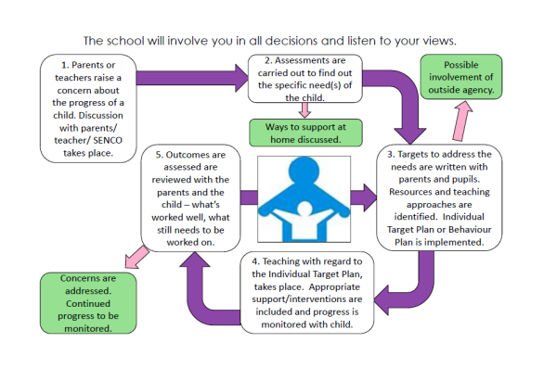



The school will try to involve your child in decisions about their learning. Here are the things we do at St Clare’s to make sure your child is listened to and involved in decision making:

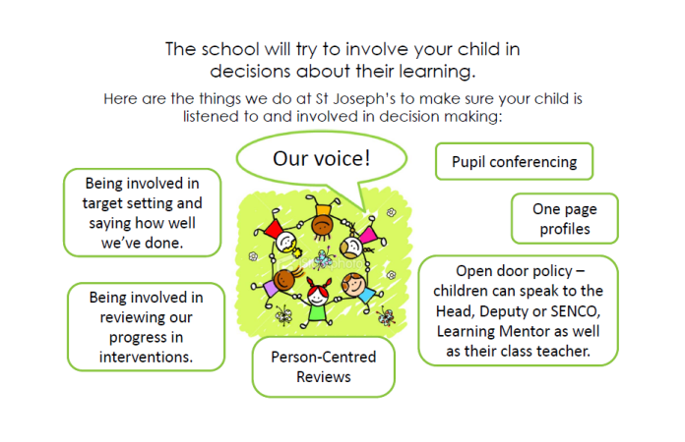

We will be happy to give you contact details for organisations who can give advice and support for you and your child. Please speak to Mrs Kavanagh if you need any other contact details.

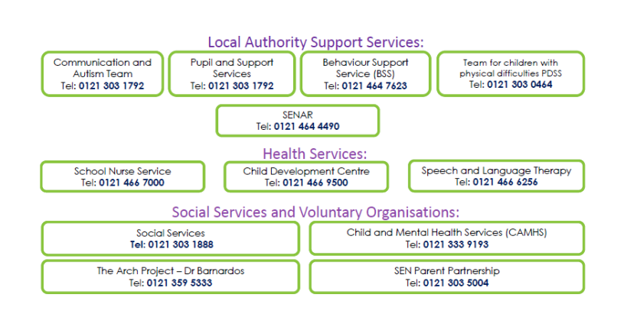



Last reviewed with parents – January 2024.