

Mini Vinnies and
Little Angels

The Mini Vinnies are the youngest members of the St Vincent de Paul Society (SVP), an international Christian voluntary organisation dedicated to tackling poverty in all its forms by providing practical assistance to people in need.
St Clare’s has a group of Mini Vinnies and Little Angels from KS1/EYFS which is made up of children from all of the different religions that we have in school and so is a multi-faith representation.
Mini Vinnie’s and Little Angels get together to live out their mission of see, think, do, supporting their school community and beyond alongside the SVP. As a dedicated Mini Vinnie, we follow a vocation to serve others and lead them in faith. Our jobs are to:
- Strengthen the faith of our school;
- Lead in class prayer and collective worship;
- Be an example of Christ’s teaching to others;
- Follow the Gospel values
- To represent all different types of religion in the school
- Meet regularly to develop the collective worship within school
- Monitor the prayer tables
- Observe child led prayer and lead by example in assemblies
- Meet regularly to develop the Prayer and liturgy within our school
- Be an example of our mission statement
- Support the needy and the sick within the local area by helping with the foodbank, making cards for the sick, Christmas and Easter cards for the housebound. Visit local homes to play games with the elderly.
- Taking part in arts and crafts to share with others
- Supporting other children in their school with SEND needs.
Mini Vinnies run lunchtime prayer clubs every Thursday. Classes are invited to join in with quiet reflection time and prayers depending on the season of the Liturgical year.
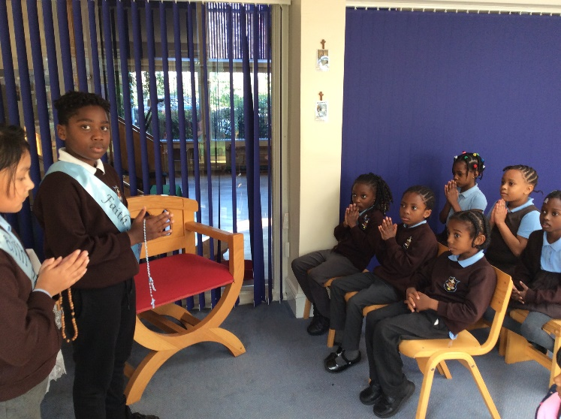
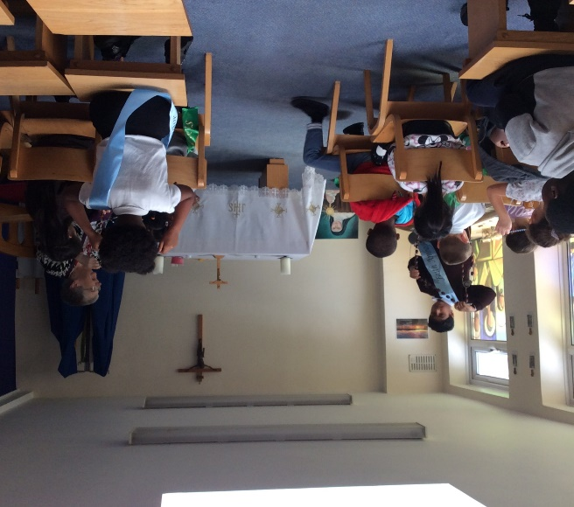
Mini Vinnies regularly meet to plan next steps. A proposal is then put forward to a member of the Senior Leadership team and or Governors.



