

Relationships and Sex Education (RSE) Policy
September 2026

St Clare’s Catholic Primary School

We are involved in relationships and sex education precisely because of our Christian beliefs about God and about the human person. The belief in the unique dignity of the human person made in the image and likeness of God underpins the approach to all education in a Catholic school.
Our approach to RSE therefore is rooted in the Catholic Church’s teaching of the human person and presented in a positive framework of Christian ideals.

Table of Contents
- Introduction
- Summary of Changes (2026 Update)
- Rationale
- Defining Relationships and Sex Education
- Statutory Curriculum Requirements
- Aims of RSE
- Curriculum Content
  - Primary Schools
- Values, Virtues, and Skills
- Inclusion and Adaptive Teaching
- Equalities Obligations
- Parental Partnership
- Safeguarding and Confidentiality
- Roles and Responsibilities
- Monitoring and Evaluation
- Implementation and Review
- Dissemination

1. Introduction
St Teresa of Calcutta Multi-Academy Company (MAC) is committed to providing a high-quality Relationships and Sex Education (RSE) programme firmly rooted in the Catholic faith. RSE forms an essential part of the holistic education of every child, supporting their spiritual, moral, social, cultural, emotional and physical development. It equips pupils with the knowledge, understanding, virtues and skills necessary to form positive, healthy relationships, make informed choices and grow into responsible, compassionate adults.
This policy provides guidance for schools across the MAC, ensuring a consistent approach while allowing each school to respond to the specific needs of its community. RSE is delivered in partnership with parents, who are recognised as the primary educators of their children. Each MAC school aims to create a safe and supportive environment where pupils can explore relationships and human development in an informed, morally grounded and age-appropriate manner.

2. Summary of Changes (2026 Update)
This policy has been updated in line with guidance from the Catholic Education Service (CES), the Department for Education (DfE, 2025), and statutory curriculum requirements. Key updates include:
- Alignment with the DfE 2025 RSE and Health Education guidance.
- Reinforced emphasis on Catholic values and virtues.
- Updated primary and secondary curriculum content, ensuring clear progression.
- Greater focus on online safety, mental wellbeing, and resilience.
- Enhanced parental engagement protocols.
- Emphasis on inclusion and adaptive teaching.
- Clarification of roles and responsibilities.
- Reinforced safeguarding, confidentiality, and pastoral support procedures.

3. Rationale
“I have come that you might have life and have it to the full” (Jn 10:10).
RSE within St Clare’s is rooted in the Catholic understanding of the human person, created in the image and likeness of God. Relationships and sexuality are gifts to be nurtured in the context of love, respect, and moral responsibility. Catholic RSE promotes human wholeness - physical, emotional, moral, spiritual and social - preparing pupils to live well in modern Britain while remaining faithful to Church teaching.
Gender and sexuality are understood as God-given gifts, and teaching emphasises the sacred dignity of the human person. St Clare’s approach recognises contemporary challenges while remaining faithful to Church moral teaching.

4. Defining Relationships and Sex Education
The DfE guidance states that “children and young people need knowledge and skills that will enable them to make informed and ethical decisions about their wellbeing, health, and relationships.” High-quality RSE promotes moral, social, mental and physical development, and cultivates positive characteristics including resilience, self-worth, integrity, courage, kindness and trustworthiness.
RSE helps pupils understand themselves as sexual beings, what it means to be fully human, and how to live in right relationships with self and others, making moral decisions in conscience.
- Primary schools: Focus on building blocks of positive relationships.
- Secondary schools: Provide the information needed to develop healthy, safe, and nurturing relationships of all kinds.

5. Statutory Curriculum Requirements
Schools are legally required to teach aspects of RSE within the National Curriculum Science. Maintained secondary schools also have statutory requirements regarding HIV, AIDS, and sexually transmitted infections.

6. Aims of RSE
St Clare’s aims to provide pupils with a positive and prudent sexual education compatible with their physical, cognitive, psychological and spiritual maturity. Working in partnership with parents, schools will:
- Promote reverence for the gift of human sexuality.
- Foster respect for the dignity of every person.
- Celebrate the goodness of creation and the human body.
- Develop responsibility for personal actions.
- Recognise and value pupils’ sexual identity.
- Encourage life-long, self-giving love within marriage and family life.
- Equip pupils to make morally informed choices and resist unwanted pressures.
- Develop knowledge of relationships, sexual health, and safety.

7. Curriculum Content
Progressive, Developmental, and Adaptive RSE
RSE at St Clare’s is designed to be progressive and developmental, reflecting the growth of each pupil as a whole person. Learning is carefully sequenced from primary to secondary phases so that each stage builds on the last. Pupils are guided to a deeper and fuller understanding of themselves, their relationships, and their responsibilities at a pace appropriate to their age, maturity and faith formation. This continuity ensures that each phase of education informs the next, supporting pupils’ ongoing moral, spiritual, emotional, and social development.
RSE is adaptive, recognising the diverse needs of individual pupils. Teaching and resources are tailored to accommodate differences in cognitive and emotional development, ability, and learning style. Pupils with special educational needs and disabilities are fully included and never withdrawn from RSE due to lack of resources or training. Staff are supported to provide differentiated teaching and specialist materials where necessary, ensuring that all children have equal access to a high-quality, morally grounded education in relationships and sexuality.
Cross-Curricular and Integrated Approach
In St Clare’s, RSE forms an integral part of whole-person education. Teaching about relationships, sexuality, and human development is embedded across the curriculum: for example, some aspects are explored in Science, others in RE, and all are informed by consistent moral and spiritual principles. Each subject reinforces the Church’s teaching on human love, fostering a coherent understanding across disciplines.
RSE is integrated with the wider life of the school, the parish and the home. Parents are fully involved in the planning and evaluation of RSE, helping to ensure that pupils hear consistent messages about the meaning and value of human sexuality in faith and life. This partnership between school, home, and parish strengthens the moral and spiritual formation of pupils and reflects the MAC’s and St Clare’s commitment to holistic Catholic education.
Co-ordinated and Balanced Programme
Effective RSE requires dedicated leadership and whole-school commitment. St Clare’s ensure that RSE is led by experienced staff with the time and expertise to co-ordinate the programme, providing support and training to colleagues. Teachers deliver lessons with confidence and enthusiasm, celebrating the Church’s teaching on love, virtue and human sexuality.
RSE is balanced, providing pupils with clear factual information alongside moral and spiritual guidance. Secondary pupils also receive statutory guidance on relevant laws, including forced marriage, female genital mutilation, abortion, and equalities legislation, ensuring that learning is both comprehensive and faithful to Catholic teaching.
Themes and Structure
St Clare’s RSE programme is structured around three core themes, adaptable to pupils’ age and ability and covering both PSHE and Catholic formation:
- Created and Loved by God – developing self-understanding, self-worth, and reverence for human dignity.
- Created to Love Others – nurturing respectful, loving relationships grounded in Christian morality.
- Created to Live in Community – Local, National, and Global – exploring pupils’ relationships with the wider world, fostering service, dialogue, and the extension of God’s Kingdom.
Each theme integrates education in virtue and religious understanding with personal, social, and health education, ensuring that teaching both reflects and cultivates the virtues necessary for human flourishing.
Christian Virtues and RSE
Teaching across all phases emphasises the development of virtues such as prudence, mercy, compassion, chastity, integrity and fidelity. These are both modelled by staff and experienced through learning, allowing pupils to internalise habits of character that will guide their moral, social and relational choices.
Curriculum Overview
EYFS 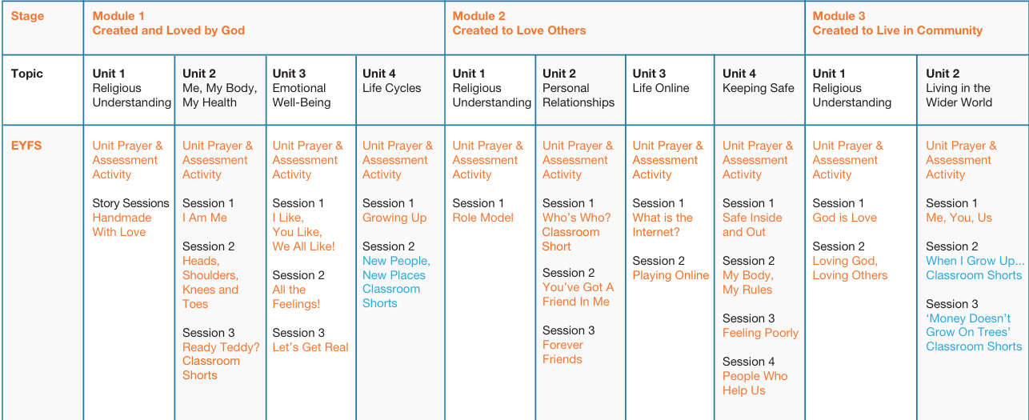

KS1
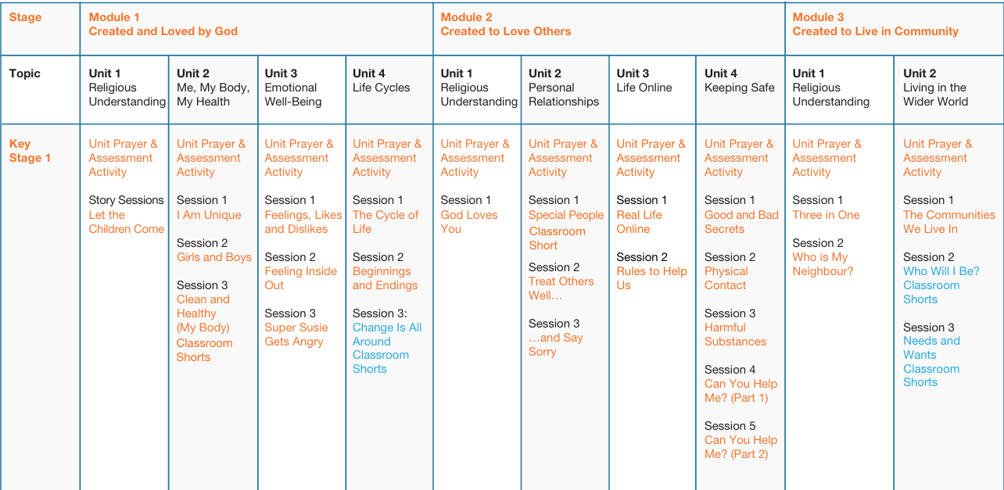

LKS2
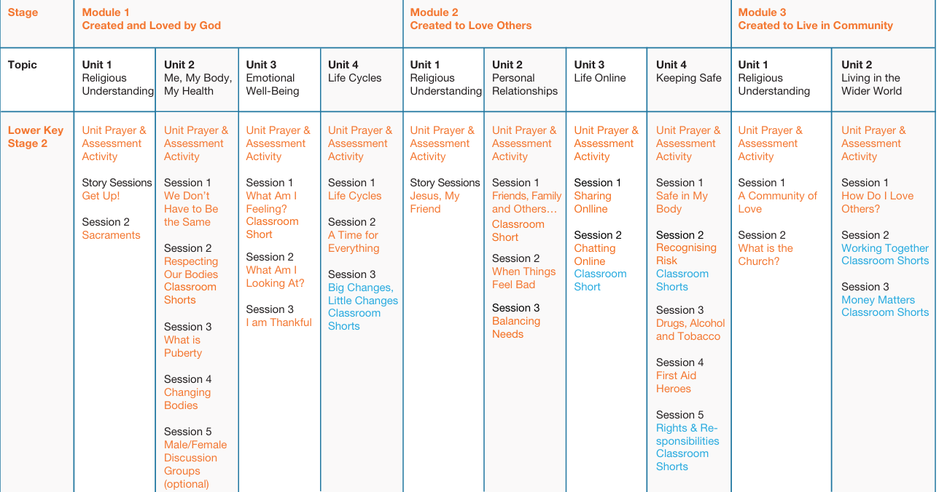

UKS2
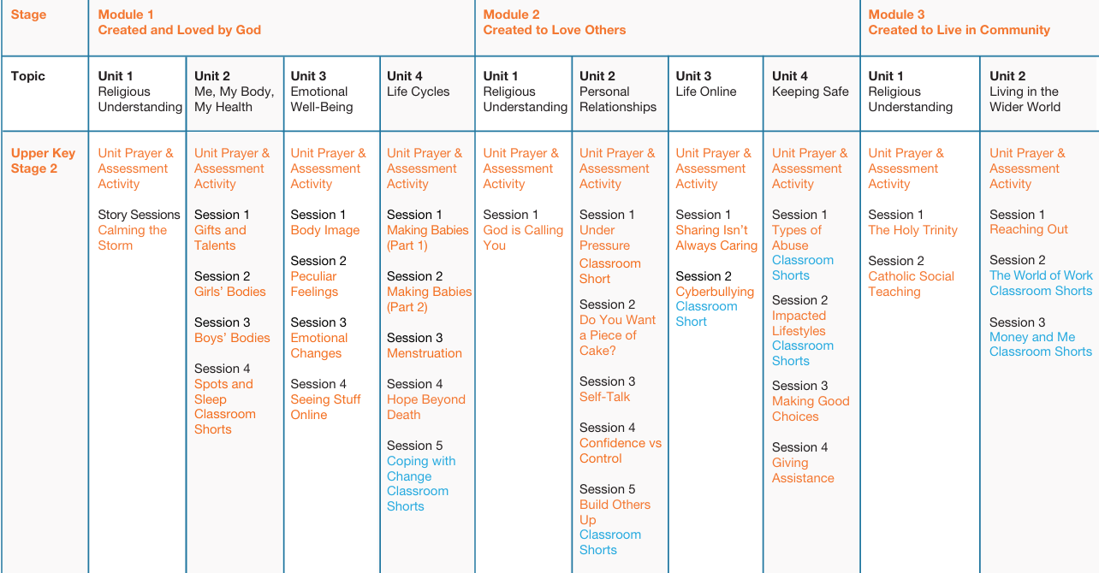

8. Values, Virtues, and Skills
St Clare’s promotes Catholic values including faithfulness, fruitfulness, chastity, integrity, prudence, mercy, and compassion. Pupils develop virtues and personal and social skills, including:
- Respect for human dignity and joy in creation
- Responsibility for actions and recognition of impact on others
- Recognition and valuing of sexual identity
- Celebration of life-long, self-giving love and fidelity in relationships
- Sound judgement and moral decision-making
- Loving relationships free from exploitation or abuse
- Emotional regulation, conflict resolution, humility, mercy, and compassion
- Self-esteem, empathy, resilience, and ability to resist pressures
- Understanding of appropriate stages in relationships and how to love chastely
- Awareness of sexual health, reproduction, and safe behaviours

9. Inclusion and Adaptive Teaching
RSE is inclusive, responding to pupils’ individual needs and differences in ability, maturity, faith, culture, or sexual orientation. Lessons promote understanding, respect and equality, addressing discrimination and prejudice, while ensuring every pupil can access the curriculum safely.

10. Equalities Obligations
St Clare’s ensures compliance with the Equalities Act 2010, supporting all pupils regardless of disability, race, nationality, sex, gender identity, religion, sexual orientation, pregnancy, maternity or looked-after status.

11. Parental Partnership
Parents and carers are the primary educators of their children. St Clare’s work in partnership through:
- advance notice of sensitive topics
- workshops
- resource provision
- consultation in curriculum planning.
Parents retain the right to withdraw their children from non-statutory sex education, with alternative provision available.

12. Safeguarding and Confidentiality
RSE may raise sensitive issues. Staff follow safeguarding procedures to ensure pupils feel safe and supported. Limits of confidentiality are explained, and disclosures of harm or abuse are addressed promptly. Pupils are encouraged to discuss issues with parents or carers.

13. Roles and Responsibilities
- Trustees and Governors: Ensure policy consultation, statutory compliance, and alignment with Catholic ethos; monitor and evaluate provision.
- Headteachers: Oversee implementation, liaise with MAC Central Team, Governors, Diocese, and authorities, and ensure consistent delivery across schools.
- RSE/PSHE Coordinators: Lead curriculum planning, staff support, and training; monitor teaching quality and resource use.
- All Staff: Deliver RSE in accordance with Catholic teaching, fostering moral, social, and emotional development.
- External Visitors: Complement teacher-led sessions and adhere to CES guidance and school codes of practice.

14. Monitoring and Evaluation
The school coordinators monitor provision through lesson plans, schemes of work, pupil work, and feedback from pupils, staff and parents. Findings inform curriculum adjustments, ensuring high-quality and consistent RSE across the MAC.

15. Implementation and Review
Implementation will follow consultation with Directors and Governors in the Summer 2026 Term. This policy will be reviewed every two years by the MAC, Headteachers, RSE Coordinators and Directors and Governing Bodies. The next review date is Summer 2028 Term.

16. Dissemination
The draft policy will be shared with all Directors, Governors and staff within the MAC. Copies will be available to parents via each school’s website and school office. Details of the RSE curriculum content will also be made available online.

