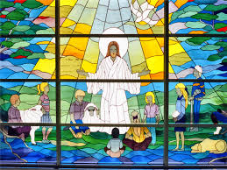

Prayer is a central part of school life at St Clare’s and children experience prayer through many forms, for example; words, actions, symbols, music and drama.

Children are invited to pray privately and as a community, as prayer unites us as members of the Family of God. They are well-formed to be able to prepare, participate and minister, at an age-appropriate level, their own experiences of prayer and liturgy as well as by enthusiastically participating in experiences provided by their peers and staff.

At St Clare’s the children learn a range of prayers and they pray many times during the school day for a range of purposes. Children at St Clare’s also learn to write their own prayers and they often choose who or what they would like to pray for, developing the liturgical formation of pupils.

Our families and communities are heavily involved in the prayer life of the school. Parents, parishioners, governors, directors and members of the community join us for Mass as well as other events such as our May Procession, class assemblies.

In recent years, we celebrated a Year of Prayer, with a particular
emphasis on the Our Father. This presented our Church with a significant opportunity to revisit the basics of prayer, and for us to become even more a people of prayer.

The Year of Prayer is not a year about prayer, but a year for prayer. The image of Christ in the manger speaks of a God who wants an intimate relationship with His creation.
Someone once said that 'prayer doesn’t help our relationship with God, prayer IS our relationship with God!' and so when we become more devoted to prayer, we are building up that Divine friendship. Being Pilgrims of Hope means that we should always be growing in our love of prayer on our journey of Faith. But the Year of Prayer also asked us to consider how we might help others to pray, so that they can experience a personal encounter with the risen Jesus.

At St Clare’s parents and members of our local community joined their child’s class Prayer workshop. Children made their own prayer box to keep at home. Children as well as their parents could write their own prayers and store in the prayer box.
A week of kindness was organised to support those less fortunate than ourselves through the power of prayer and charity fundraising for the NSCPP.
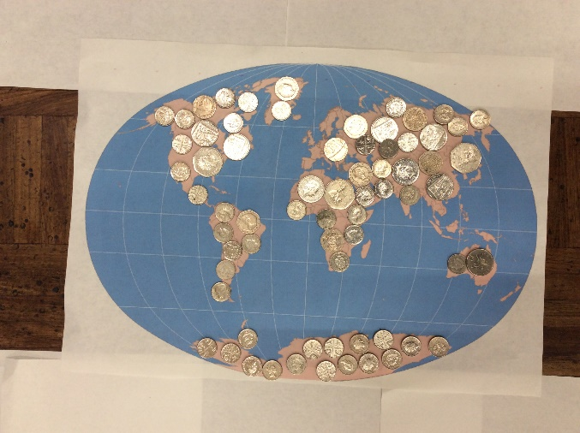

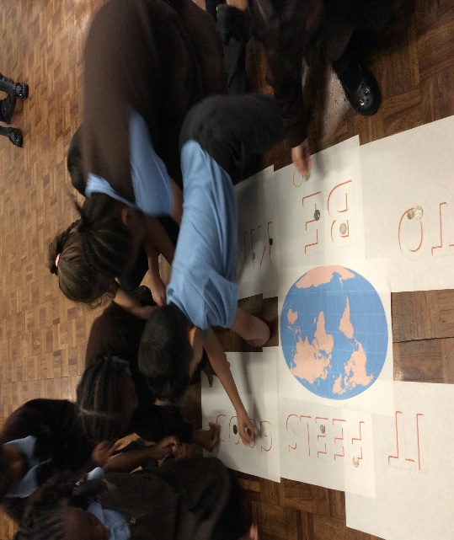

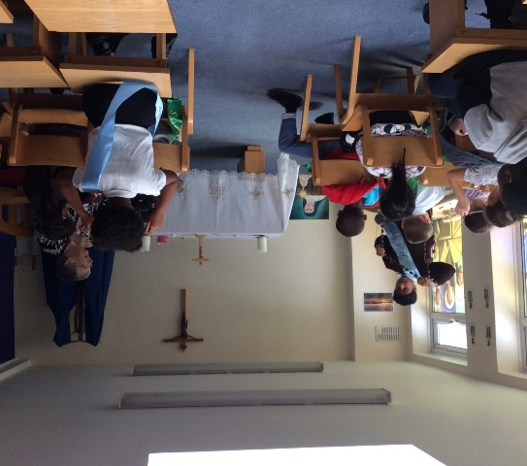
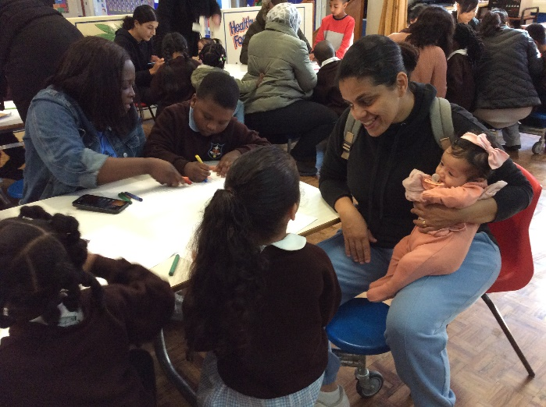

Traditional Catholic Prayers
The children are also taught a range of traditional Catholic prayers. These are incorporated into class collective worship, RE lessons and whole school celebrations. These are also shared with our families so the children can share them at home. Here are an example our Prayer Books, which contains the prayers that children at St Clare’s learn during their time here:
- Our Prayers

Staff and Governor Prayers
Staff are enthusiastically devoted to the mission of St Clare’s and every Friday morning, all the staff at St Clare’s gather together to share carefully-chosen scripture, prayer and reflection. This collective act of worship, always respectful of the diversity of staff backgrounds and beliefs, is a way of professing our shared values and reminds us of our common purpose.

Before every Governors’ meeting, we invite our governor to join our SLT for some time in prayer. It is lovely to join together to reflect and pray about the importance of our work, the difference we all make and to give thanks for the support of our governors.

