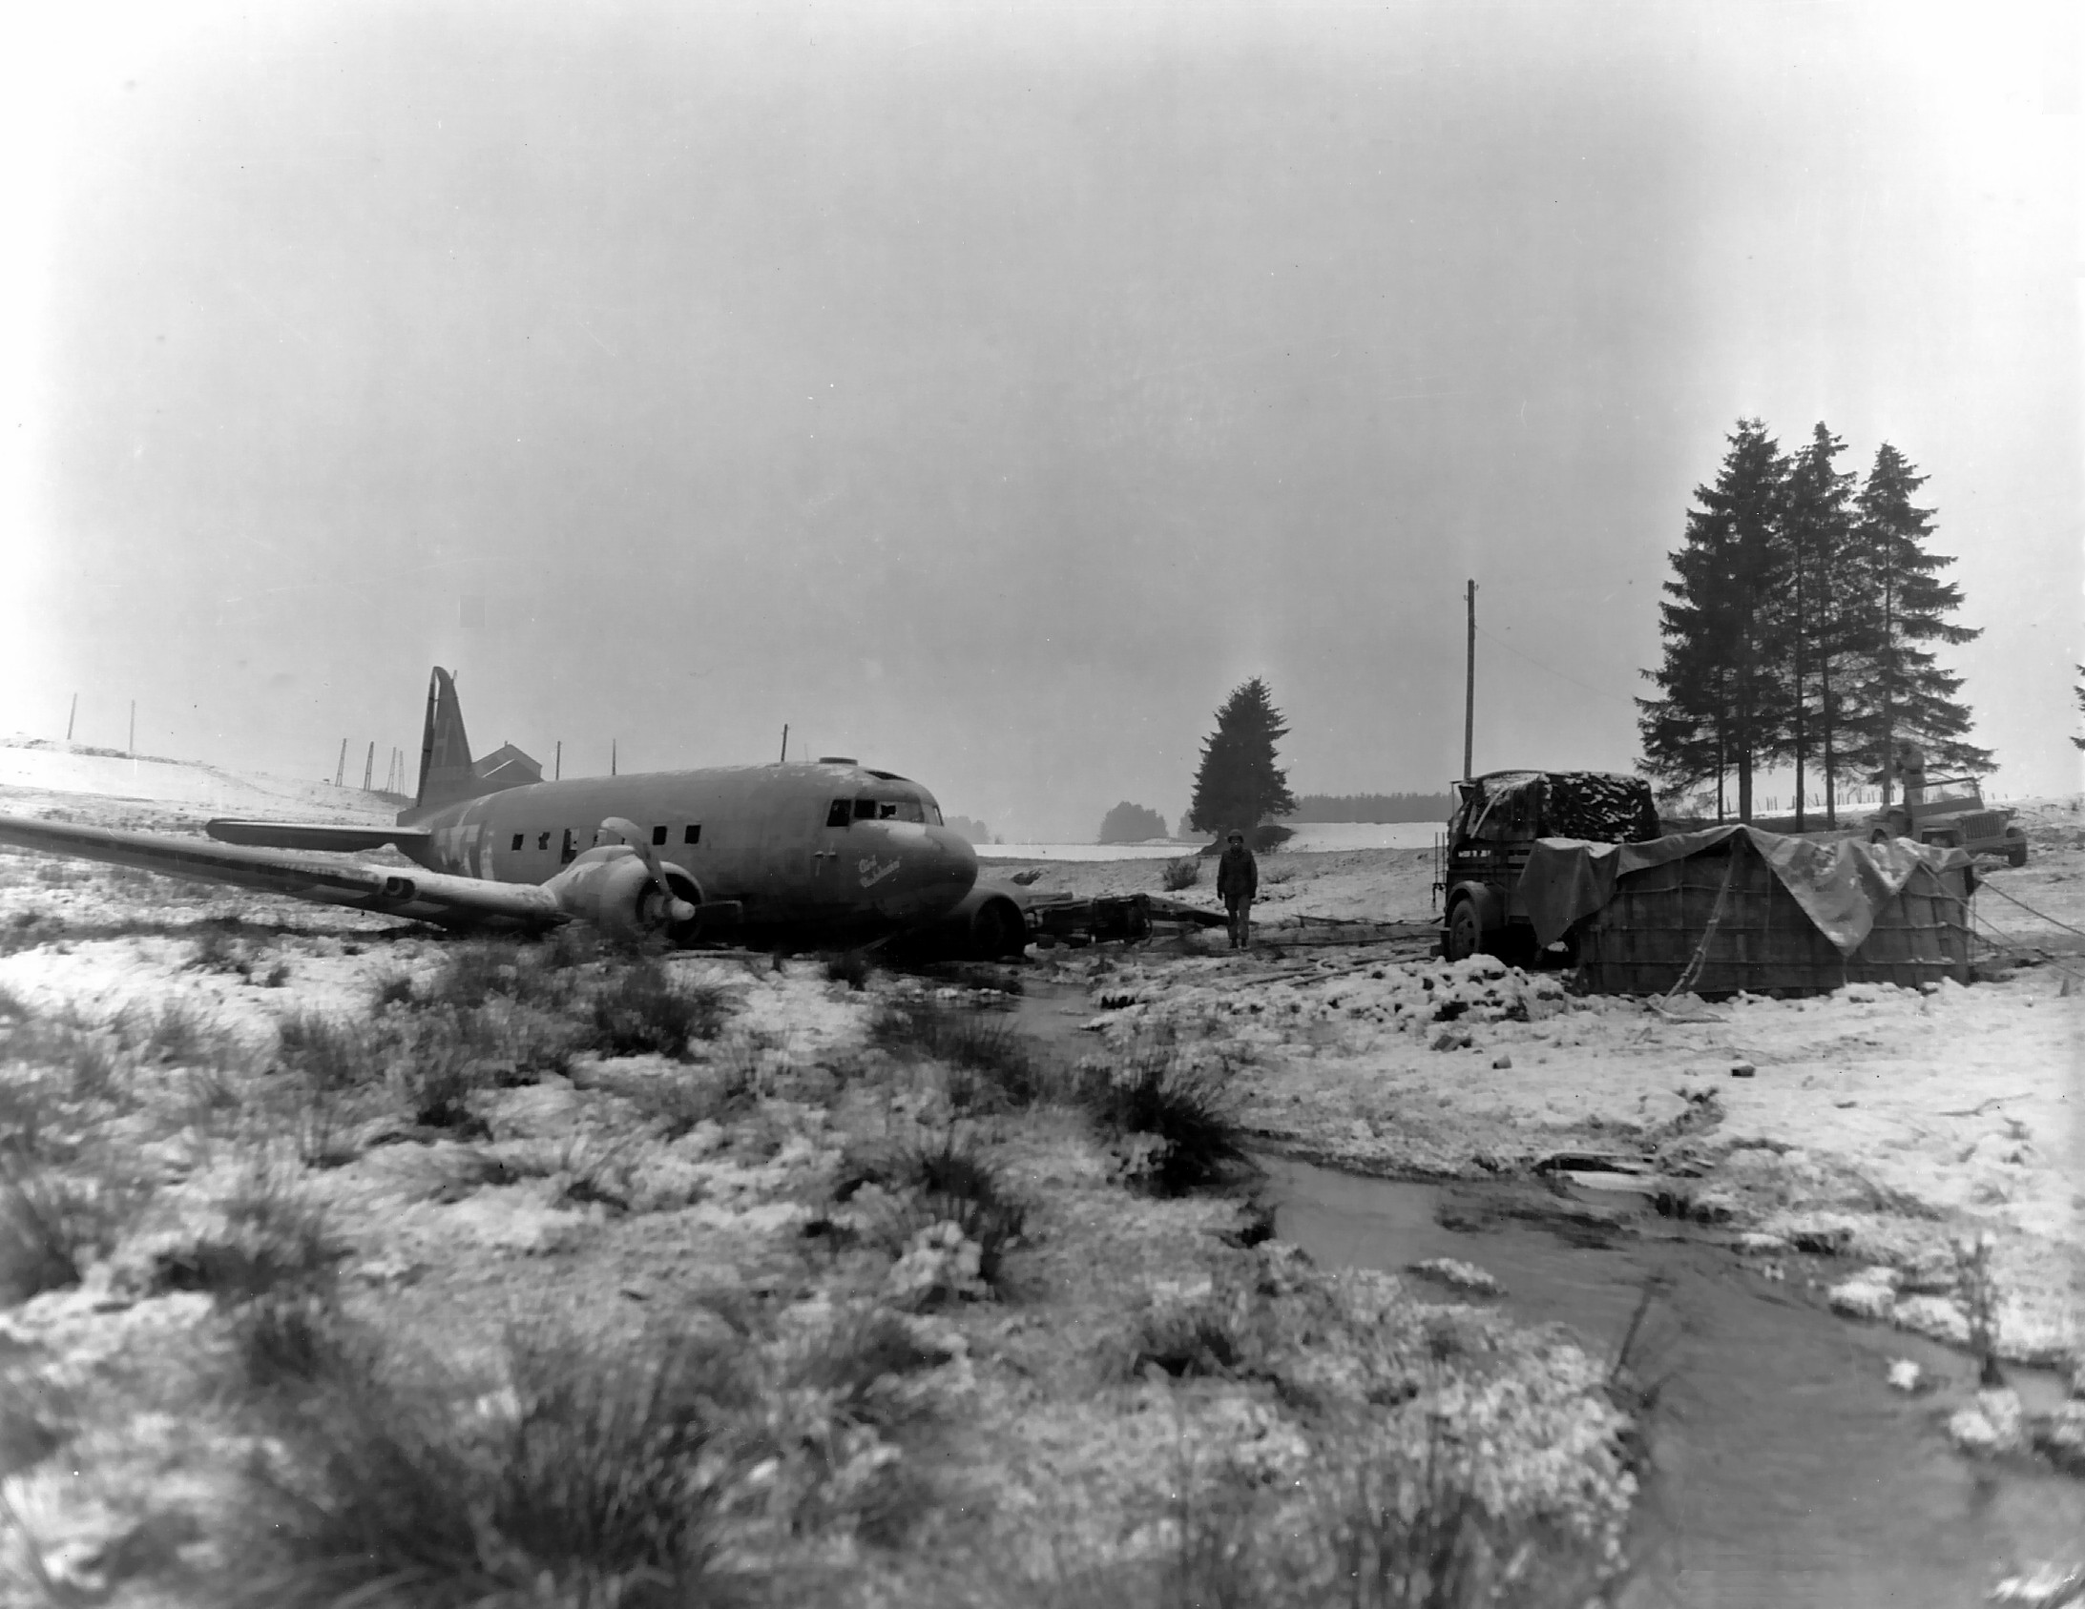

**Science**

**Animals including humans, circulation and nutrition.**

* Describe the functions of blood and blood vessels.
* Describe the function of the heart.
* Describe the way in which nutrients and water travel through the body.
* Recognise the impact of diet.
* Recognise the impact of exercise on pulse rate.

**Evolution and inheritance**

* Recognise that living things have changed over time.
* Recognise that some traits are inherited characteristics.
* Recognise that living things produce offspring of the same kind.
* Identify how animals are adapted to suit their environment.
* Identify that scientific evidence that has been used to support or refute an idea.

**Religious Education**

**Creation**

* To know that there are two stories of creation in the book of Genesis.
* To understand what being made in the image and likeness of God means.
* To understand we have the responsibility to use our God given talents.
* To know some reasons for praising God the creator of the world.

**Baptism**

* **To** be able to reference Gospel accounts of the Baptism of Jesus.
* They will be able to describe, sequence and explain many of the sign’s symbols and actions in the Sacrament of Baptism.

**Advent**

* To know that there are two parts to the season of advent.
* To know how Christians’ prepare for the second coming of Christ.

**English**

**Autumn Texts (Read in school)**

‘The boy in the striped pyjamas’ by John Boyne

Suggested home readers

‘When Hitler stole pink rabbit’ by Judith Kerr and ‘Private Peaceful by Michael Morpurgo

**Reading**

To infer information about characters from their thoughts, actions and feelings.

To justify answers using evidence from the text.

To understand an author’s choice of language.

To predict using information stated and inferred.

To read and perform poetry with intonation and expression.

**Writing**

Diary writing

Non-chronological reports

**Grammar and punctuation**

Passive and active verbs

Subordination

Cohesive devices within and between paragraphs

Semi-colons, colons, dashes, brackets and commas.

Revision of grammatical terminology such as noun subject, object, active, passive, synonym, antonym and an ellipsis.

**Composition**

Emphasis on purpose, audience, format and ‘authors voice.

Character development

**Spelling**

Common Exception words for Y5 and Y6

Homophones

Prefixes and suffixes as listed in the KS2 spelling document.

**P.E.**

**Gym and Dance**

Agility: changing and controlling direction and position

Performance: conduct, accomplishment, achievement, completion, fulfilment, implementation, execution, presenting, improving, refining

Spatial awareness: awareness, understanding of self and objects within a space, changes in position

Co-operation: collaboration, working together, combined effort, teamwork, partnership, coordination

**Oracy**

“I would like to start by saying…”

“Building on to what _____is saying”

“I respectfully disagree because…”

**Mathematics**

* Read, write, order and compare numbers up to 10 000 000 and determine the value of each digit.
* Round any whole number to a required degree of accuracy.
* **Use negative numbers in context and calculate intervals across zero.**
* Solve number and practical problems that involve all of the above.
* Multiply multi-digit numbers up to 4 digits by a two-digit whole number using the formal written method of long multiplication.
* **Solve problems involving addition, subtraction, multiplication and division**
* Identify common factors, common multiples and prime numbers
* Perform mental calculations, including with mixed operations and large numbers
* Solve addition and subtraction multi-step problems in contexts, deciding which operations and methods to use and why.
* Use common factors to simplify fractions; use common multiples to express fractions in the same denomination.
* Compare and order fractions, including fractions greater than 1.
* **Add and subtract fractions with different denominators and mixed numbers, using the concept of equivalent fraction.**
* Identify the value of each digit in numbers given to three decimal places and multiply and divide numbers by 10, 100 and 1000 giving answers up to three decimal places.
* Multiply one-digit numbers with up to two decimal places by whole numbers.
* Use written division methods in cases where the answer has up to two decimal places



**French**

French Grammar e.g. I like, I enjoy and I dislike.

The theme is School

**D&T or Art**

**Food Unit 1**

* Find out about important people and events in the past that have shaped the way bread is made and sold today.
* Investigate and analyse existing products according to their characteristics.
* Develop a design criteria and shape dough.
* Think of original ideas for a product based on my design criteria.

|  |
| --- |
| * Use research and develop design criteria fit for   Purpose aimed at particular individuals or groups. |
| * Select ingredients and kitchen equipment to follow a   bread making recipe (knead and bake).  **Artist Study**   * Draw a self-portrait focusing on perspective, line, tone, shading and accuracy. * To consider the effects of colour. * Use water colours and appropriate techniques. * To create 3D images using clay (using the work of Henry Moore as a stimulus). |

**Computing**

**Research skills**

* Recognise when someone is upset, hurt or angry online.
* Describe how to get help for someone that is being bullied online and assess when I need to do or say something or tell someone.
* Explain how to block abusive users.
* Explain how I would report online bullying on the apps and platforms that I use.
* Describe the helpline services who can support me and what I would say and do if I needed their help (e.g. Childline).

**Music**

**Performance**

* Play and perform in solo and ensemble contexts, using their voices and playing musical instruments with increasing accuracy, fluency, control and expression.
* Influence and compose music for a range of purposes using the interrelated dimensions of music.

**SMSVC/ Gospel values**

* Truthful and Eloquent
* Learned and Wise

**PSHE**

* Peer pressure
* Bullying
* Developing independence
* Positive body image

**History or Geography**

**Maps**

* Physical Geography- features of Northern Europe.
* Comparison (England and Poland)
* Understand how to use an OS map and the appropriate symbols.
* Understand the term hemisphere, longitude, latitude, time zones and Arctic Circle.
* Describe and understand key aspects of human geography.
* Use the 8 points of a compass.

**World War 2**

* Place historical events in chronological order.
* Understand the meanings of AD and BC.
* Research evidence using primary sources.
* Know some of the experiences of evacuees.
* Know what happened to Jewish people living in Germany in WW2.
* To begin to understand how the past has been represented in different ways.
* Address historically valid questions about change, cause, similarity, difference and significance.

